**Network Simulation Software**

**A comparative analysis**

**Aslam Patel**

Contents

Abstract 2

1. Introduction to Computer Network Simulation 2

1.1 Concepts in network simulation 2

1.2 Simulators 2

2. Network simulators 3

2.1 NS2 3

2.2 NS3 4

2.3 OPNET 4

2.4 OMNET++ 5

2.5 NetSim 6

2.6 QualNet 6

2.7 Comparison of Simulators 7

**3.** QualNet VS NetSim 8

3.1 NetSim: 8

3.2 QualNet 13

**4.** Conclusion 18

## Table of figures

Figure 1 Table of comparison 7

Figure 2 Plot window which shows average throughput 8

Figure 3 NetSim Simple network design 9

Figure 4 NetSim Node Properties 10

Figure 5 NetSim Simulation Time settings 11

Figure 6 NetSim CLI for simulation 11

Figure 7 NetSim Metric Presenter 12

Figure 8 QualNet Layer Model 13

Figure 9 QualNet Blank Animator 14

Figure 10 QualNet Animator with inputted nodes 14

Figure 11 QualNet Animator with traffic generators 15

Figure 12 QualNet CBR amendment 16

Figure 13 QualNet Time set for simulation 16

Figure 14 QualNet Running animator 17

Figure 15 QualNet 3D view of Animator 18

## Abstract

In this study I aim to compare 6 different network simulators. I aim to study history, technical features, advantages, and drawbacks of these 6. Also, I will be studying two network designs one using QualNet and one using NetSim. The QualNet Design I will create myself and will just be a simple network and the NetSim simulation will be one that is open source and gained access too to study.

# Introduction to Computer Network Simulation

Simulation plays an essential role in tech in contemporary time. Over the last decade network simulation has become progressively more valuable due to the swift development of the internet in general. Systems can be modelled at different levels of detail, circuit level, Block level, system level, but what is the difference between modelling and simulation? A model is a skewed view of the systems complexity and concentrates on specific factors of relevance. However, simulation is a method. This method is used to model the system or to solve an issue using a computer software.

Computer aided simulation can prototype proposed and real time events on a pc to survey the properly made configuration. A network simulator is an entity of employing the network on the pc by means of which the application of the network is determined. The pc aided simulation tools are utilized in the simulation of networking systems.

Researchers can test various scenarios to see what the most efficient way will be to implement in a real-world setting. An in depth and detailed design can be created using nodes, hosts, hubs, bridges etc.

# 1.1 Concepts in network simulation

Network simulators usually attempt to replicate a real-world network, and this is the factor which makes it useful. As they can calculate the interaction between various components using arithmetic calculations.

The networks can be formed according to the constraints by utilizing the various tools, functions and links that would replicate a true network. Additionally, this software permits clients to generate numerical diagrams and evaluate the outcomes founded within networks they have produced. Similarly, analysing/testing multiple characteristics and producing findings built on this.

Upon receiving this data via simulation, the data can now be observed and analysed. Amendments can be made to see how the programme will react under different circumstances.

As simulation programmes can be used and analysed simultaneously using different links, strategies etc. users of simulation can adjust the simulator to suit their particular requirements and wants. Simulators care for common protocols such as WLAN and TCP.

# 1.2 Simulators

Nearly all the current used simulators are GUI (graphical user interface) powered however there are still some that are led by CLI (command line interface). One of the main outputs of a simulation is the fact that it can trace files which has packet log files on every stage of transmission which can be used for mass analysis. It can also output event triggers i.e., when a packet has arrived due to a node triggering that event

# Network simulators

There are plenty of simulators which are widely available. Examples are as follows.

1. NS2

2. NS3

3. OPNET

4. OMNeT++.

5. NetSim

6. QualNet

## NS2

**Type:** Open source

**Languages:** OTCL & C++

**OS:** Windows, Linux & Mac

NS2 is an event simulator which was licensed in 1996 for public use, in which it the timing of all events are maintained in a scheduler. It has 2 languages that it uses, one of which is the system language which is C++. It uses C++ as it is fast and strong language, which is used across the globe for various programmes, its scripting language is called OTCL which is used for high level programming but is less efficient. It supports the use of wireless and wired simulation and provides the usage of TCP, UDP etc.

**Features:** the OTC which is used by NS2 is used by composing a script which defines a network, the destinations of the network, network traffic, protocols etc. the NAM (network animator) is a programme within NS2 that grants the user the ability to visualise packets as they work their way through the network.

* Routes across numerous paths
* Wireless modules
* Ad-hoc networks supported
* Has mobile hosts which supports the use of cellular networking

**Advantages:**

1. Shows traffic patterns and provides an effective energy model
2. Has a numerous amount of models
3. Density of situations can clearly be investigated

**Drawbacks:**

1. recompilation is required each time when there is any change in the code by the user
2. if there is a complex infrastructure that needs to be modelled, this will be too complicated for NS2

## NS3

**Type:** Open source

**Languages:** C++ & python

**OS:** Windows, Linux & Mac

NS3 is a simulator which again is used for research and testing. NS3 had the main aim to replace NS2 by trying to resolve the obstacles which were in NS2. Unlike NS2, NS3 is used for internet simulation rather than wired and wireless. NS3 was not actually built on NS2 rather it being built new.

**Features:**

* C++ programmes
* Python scripting
* Revised models
* Combination of software’s
* Resembles real networks

**Advantages:**

1. Higher modularity than NS2
2. TCP, UDP IPv4 all supported
3. Increased flexibility compared to NS2

**Drawbacks:**

1. Lack of integrity
2. Upholders are required
3. Active upholders are needed to satisfy user queries, bugs and always aid the validation of the system.

## OPNET

**Type:** Commercial

**Languages:** C++ & C

**OS:** Windows

OPNET was originally developed at MIT in 1987 and was deemed to the first ever profitable network simulator. It had the ability and tools to build various network models such as WAN, LAN etc. and the tools to build, perform and debug. It also had a interactive debugging engine which was built within the software and came with a lot of usage tutorials and documents.

**Features:**

* Cohesive evaluation tools
* Object orientated modelling
* Geographical modelling
* Animation
* An interactive debugging engine.
* Library of protocol models
* Library of network devices.
* Parallel distributed simulation

**Advantages:**

1. Influence 3 separate simulation tools to effectively trade off simulations detail
2. Provides a graphical environment
3. Wireless that can be customised
4. Fast discrete event simulation engine

**Drawbacks:**

1. complex GUI
2. not a lot of nodes are allowed within a separate linked mechanism
3. the precision of the findings is restricted by sample resolution

## OMNET++

**Type:** Open source for academic and non-profit use

**Languages:** C++ main. Supports C# & Java

**OS:** Windows, Linux , Mac & UNIX systems

OMNET++ stands for ‘objective modular network tested in C++’. It is an opensource modular and component-based simulator like its predecessors NS2 & NS3. This simulator is mainly used for educational and research needs.

It also offers and eclipse IDE and a graphical runtime environment.

**Features:**

* Simulation kernel library
* Compiler for NEDC which is the topology language used.
* GNED (graphical network editor)
* Visualization tools
* Model documentation tools
* Has the ability to execute CLI for simulation

**Advantages:**

1. Offers strong GUI workspace
2. Tracing and debugging are much simpler in comparison to other simulators.
3. Wireless modelling is customizable
4. Accurate modelling of nearly all hardware

**Drawbacks:**

1. Does not offer a large variety of protocols which leaves users with a lot of effort
2. Weak evaluation of standard implementation
3. Mobility extension is inadequate

## 2.5NetSim

**Type:** Proprietary

**Languages:** C & Java

**OS:** Windows (.NET framework needed)

NetSim is an event simulation software which was developed by Tectos in 1997. This was created with in union with the Indian Institute of science. NetSim comes along with an built in advancement environment where it operates as an interface amongst the user’s code and the NetSim protocol libraries. NetSim is obtainable via a standard or educational version.

**Features:**

* Simulates wide range of routers
* As the protocol libraries are opensource this can be modified by the user
* Has better debugging technologies
* Modelling and simulation backing TCP, UDP, IPv4 and IPv6 routing.

**Advantages:**

1. Great GUI design which included a drag and drop for devices
2. Analysis framework which gives an inter-protocol performance evaluation
3. Easy to learn and get a grasp of using the software
4. The packet flow can be visualised using the built-in animator

**Drawbacks:**

1. A free edition of NetSim is not offered
2. Single event queues are utilized for replication and always includes one entry for each station on the network

## QualNet

**Type**: Commercial (however they have licenses)

**Language**: C++ (Object orientated)

**OS**: UNIX, Windows, Mac, ubuntu & Linux

QualNet is short phrase for quality networking which was created in early 2001. This is a profitable version of ‘GloMoSim’. QualNet is only written in C++. It is an high reliability network simulation software which calculates wired or wireless networks and the execution of them devices.

**Features**:

* Allows real time speed of network running
* Can run numerous evaluations by differing model, network, and traffic factors in a very quick timeframe
* Can model over a thousand of nodes by using the latest hardware to be advantageous to the simulation. Can support 600 to 25,000 nodes
* It can be processed on a cluster, multicore and multiprocessor structures which be used to model very large networks.
* It can connect to external hardware and software application. An example being OTB or graphical software to aid network model.
* Can aid to design new protocol models and enhance current models

**Advantages:**

1. Endorses multiprocessor structures and distributed computing
2. Simulates both wired and wireless
3. An easy GUI to use
4. Has animation resources
5. Runs on a cluster, multicore, and multiprocessor systems

**Drawbacks:**

1. Linux installation can be difficult for some users
2. Java based UI can be very slow
3. Can be expensive to install

## 2.7Comparison of Simulators

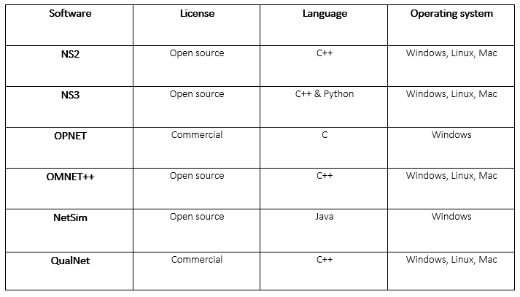

Figure 1

# QualNet VS NetSim

NetSim is an event simulation software that uses Java which comes along with an in-built development environment which operates as an interface between the user’s code and the NetSim protocol libraries. Whereas QualNet is only written in C++. It is an high reliability network simulation software which calculates wired or wireless networks and the execution of them devices

The technologies that regulate wireless access are often grouped using distance and speed. There are some examples which are as follows.

* WPAN (Wireless personal are network)
* WLAN (Wireless local area network)
* WMAN (Wireless metropolitan area network)
* WWAN (Wireless wide area network)

## 3.1 NetSim:

NetSim comes along with an in-built development environment which operates as an interface between the user’s code and the NetSim protocol libraries. NetSim is obtainable via a standard or educational version.

Users of NetSim can readily design, model, and simulate all the above wireless network types using access points, nodes(wireless & wired), routers & switches. Using a drag & drop graphical user interface permits the users to quicky create a visual network and set its properties. One of the main aims of NetSim is that it permits the experimenter a good amount of flexibility in identifying the network and the traffic that will be generated from this network.

It has a Great GUI design which included a drag and drop for devices. The packet flow can be visualised using the built-in animator. It also includes analysis framework which gives an inter-protocol performance evaluation and ultimately is easy to learn and get a grasp of using the software

NetSim supports numerous communication protocols which can be included in simulation testing. The protocols include

* 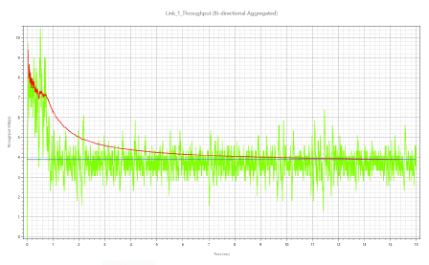Ethernet OPC & Modbus

Figure Plot window which shows average throughput

* Serial Modbus

NetSim has many WLAN protocol capabilities such as MAC layers, RF propagation, Propagation Models, PHY layers. NetSim also consists of a latency, packet loss and plot tab. The plot window is a time series which shows throughput plots as a moving average shown in figure 3

Path Loss Models:

* Friis Free Space
* Log Distance
* COST231 HATA Suburban
* COST231 HATA Urban
* HATA Urban
* HATA Suburban

I studied a NetSim network model in which the user created a simple WLAN network. I did make an attempt to create a similar task to what I will be doing with QualNet however it seemed due to the sheer power of NetSim my device was unable to handle this.

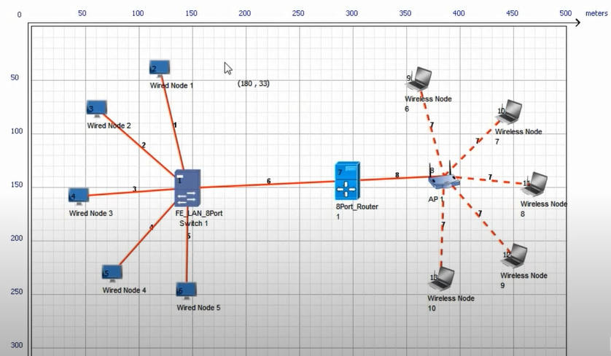

Figure NetSim Simple network design

The user used the dropped and drag GUI to place all components and wired the links up using wired and wireless links. The AP allowed wireless LAN functionality and were again linked using wireless links. The wired link was connected with the LAN and WLAN networks (both LAN and router)

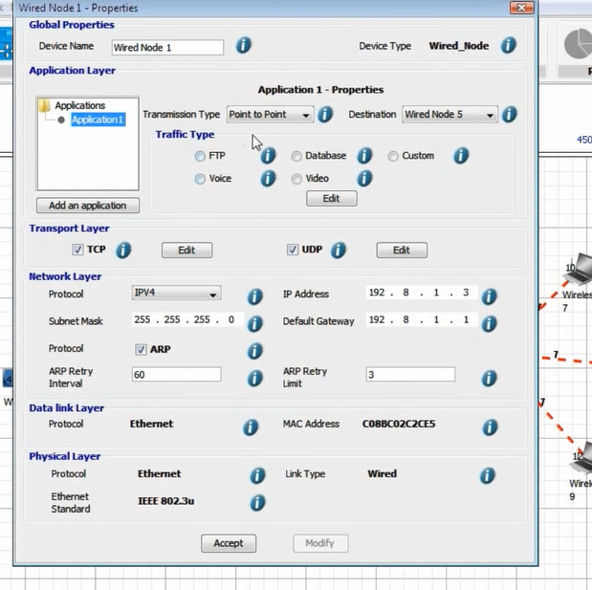

Figure NetSim Node Properties

By right-clicking on the device and selecting properties the user was able to see the node is modelled for the bilayer tcp/ip stack and has five layers in the application layer. users can select the transmission type as either point-to-point or broadcast then the user can choose from kinds of traffic models available like FTP. In this example the user selected FTP.

An in the network layer users can set the IP address subnet mask default gateway and ARP properties.

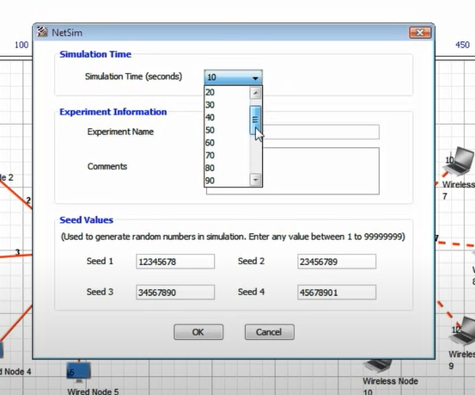

Figure NetSim Simulation Time settings

now the user has created and configured the scenario the next step that he took was to simulate it. For that he clicked the simulation button and before the simulation is run. Also the option to add experiment name and comments can be added for future recall on this specific project.

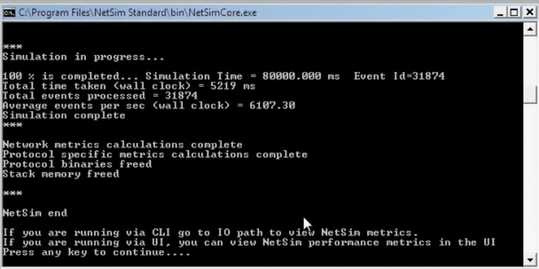

Figure NetSim CLI for simulation

command-line window opens and display various messages indicating the simulation progress and this continues till the simulation is complete.

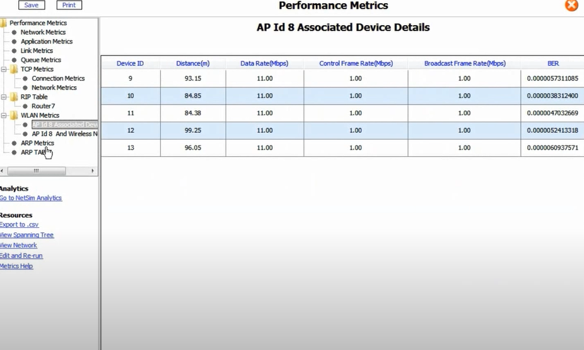

Figure NetSim Metric Presenter

After the simulation is over NetSim reports various performance metrics like network metrics, application metrics, link metrics, tcp metrics, WLAN metrics, and much more

## 3.2 QualNet

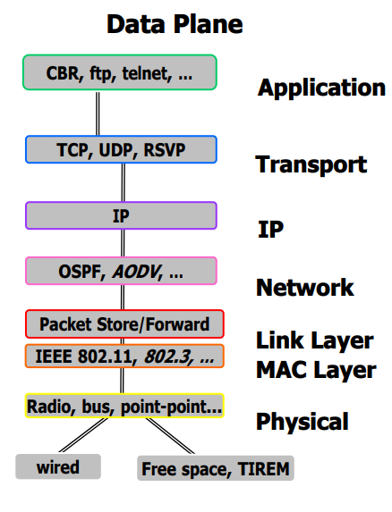

The developer tool kit includes the following.

* animator: which is a gui tool
* Designer: graphical machine based custom protocol design tool
* Analyser: used for custom statistics collection
* Tracer: used for packet tracing and visualisation

Prerequisites include.

* C compiler
* Java (up to date version)
* A QualNet license

QualNet supports a wider range of networks such as.

* MANET
* QoS
* Wired
* Cellular

Figure QualNet Layer Model

**Features**:

* Allows real time speed of network running
* Can run multiple analysis by varying model, network, and traffic parameters in a very quick timeframe
* Can model thousands of nodes by using the latest hardware to be advantageous to the simulation. Can support 500 to 20,000 nodes
* It can run on a cluster, multicore and multiprocessor systems which be used to model very large networks.
* It can connect to external hardware and software application. An example being OTB or graphical software to aid network model.
* Can aid to design new protocol models and enhance current models

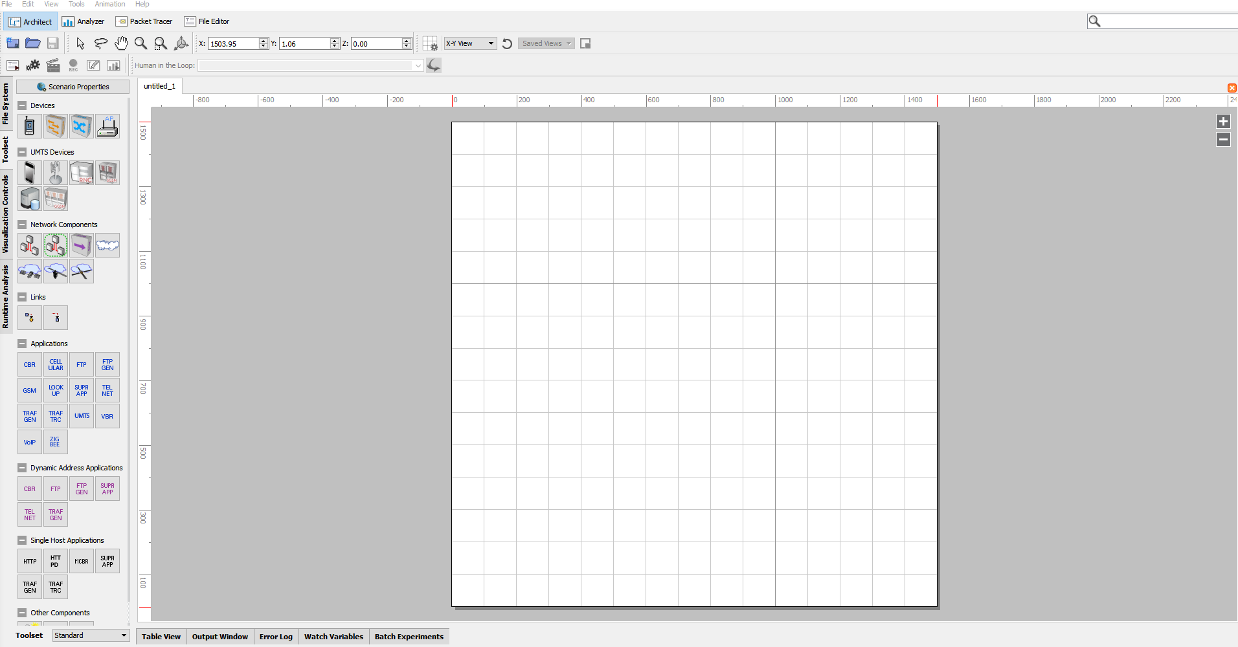

Figure Blank Animator

I started by adding 11 nodes with node 1 acting as the data sink. All 11 nodes the following was changed.

Radio type 802.15.4 radio

MAC protocol 802.15.4

Routing protocol AODV

IP fragmentation unit 70

Mobility model Random

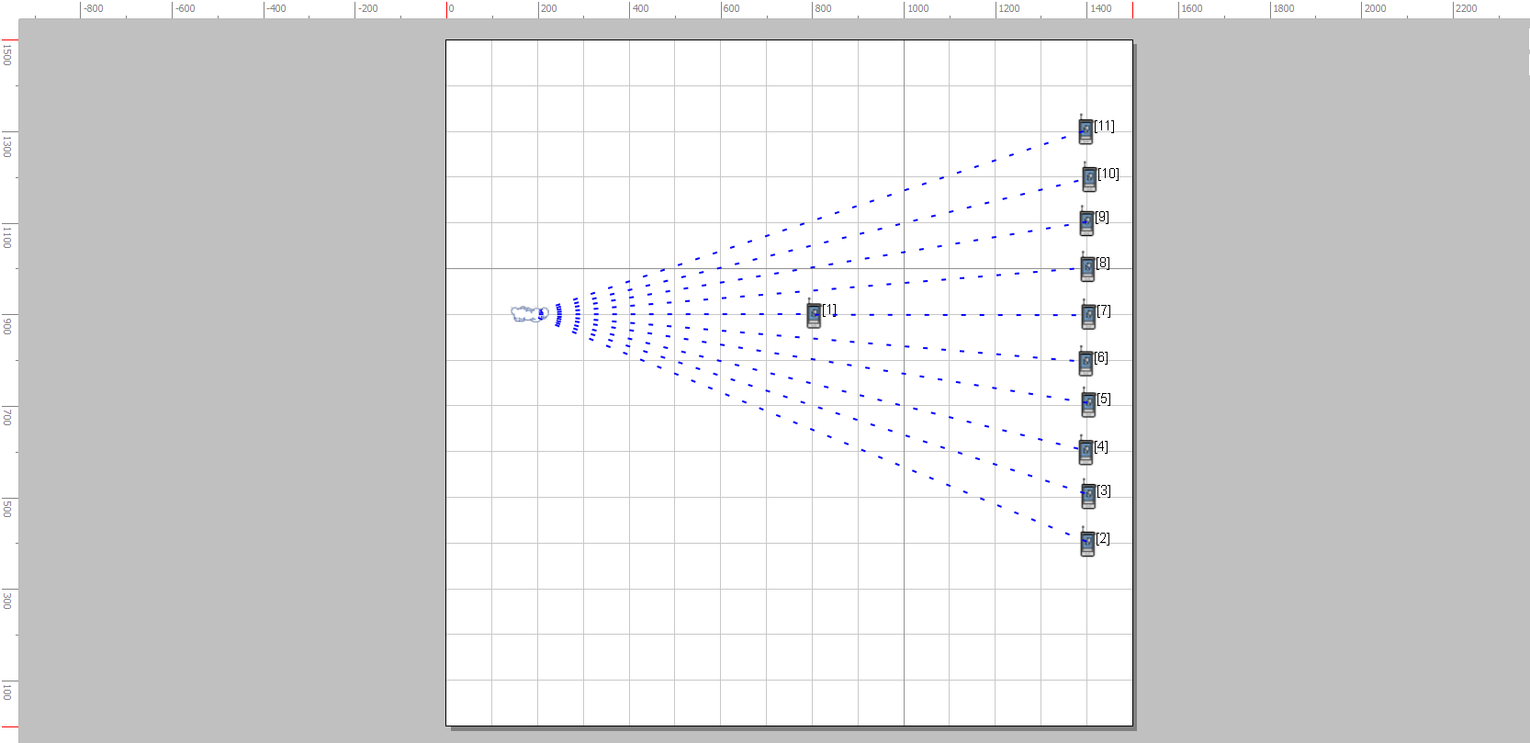

Figure QualNet Animator with inputted nodes

I then amended the data sink which in my case is Node1 and changed the following.

Mobility model none

MAC protocol 802.15.4

Device type Full function

These settings are necessary to get the root node act as PAN Coordinator which is necessary in each 802.15.4 wireless network

As traffic generators were missing I added CBR and linked all sensor nodes with the root node. A PAN coordinator ensures the network is operating properly and is supporting the network often it is the key node in the network. It lets that node to converse with the more nodes and give messages to them. Shown in figure 4.

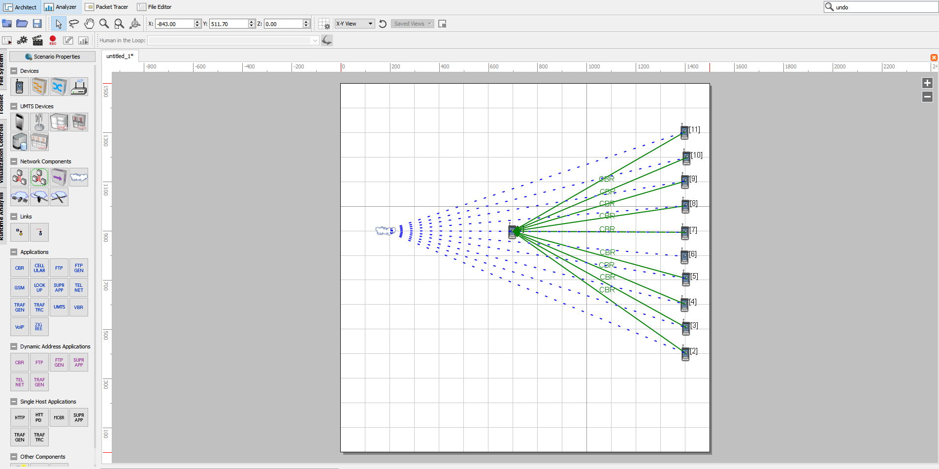

Figure Animator with traffic generators

I then amended the items to send to 30 and kept 512 bytes as standard

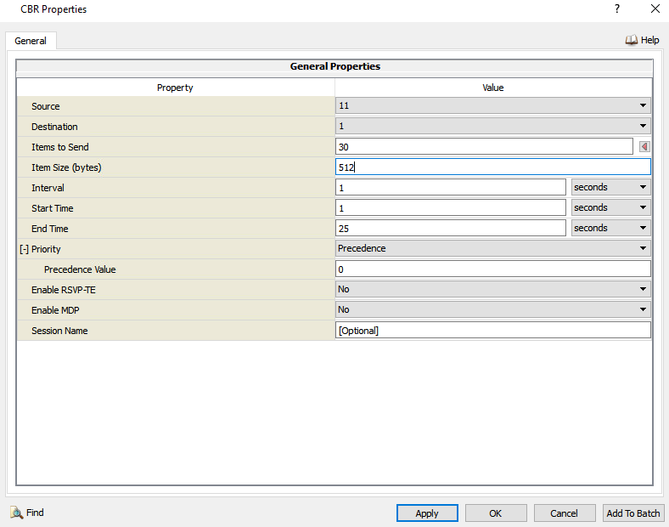

Figure CBR amendment

And finally set simulation time to 30 seconds

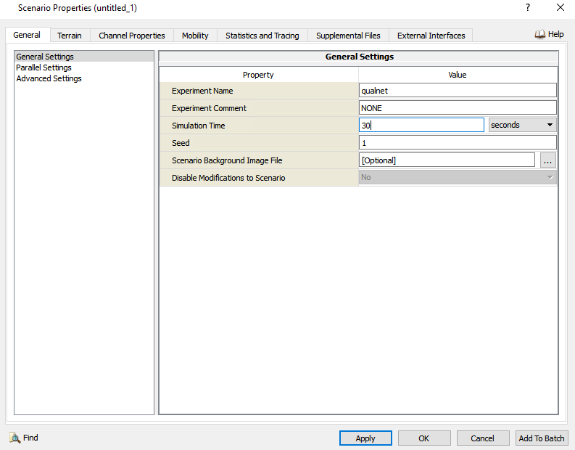

Figure Time set for simulation

To get a concept of how the development works it can be run by means of the QualNet Animator

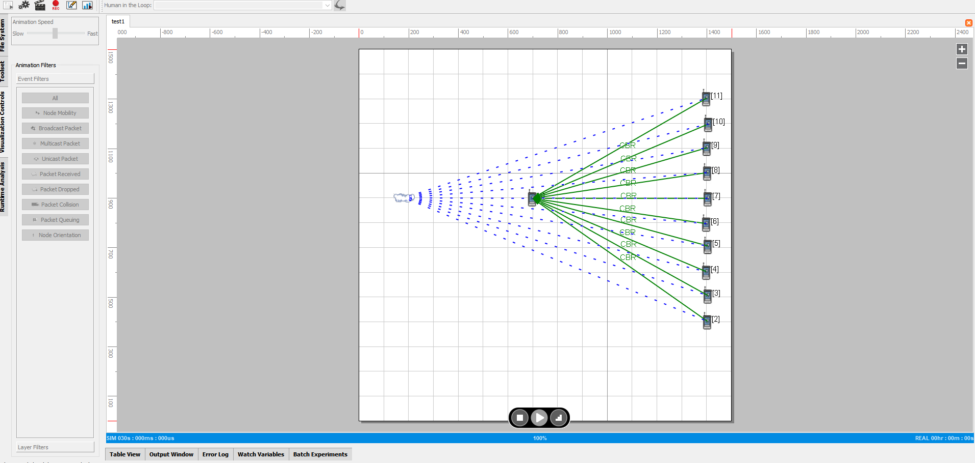

Figure Running animator

Also gained access to 3d view

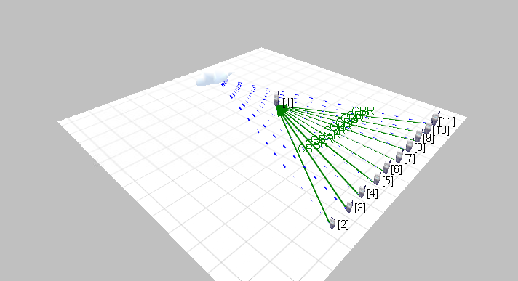

Figure 3D view of Animator

This network which was created was small and simple when in real time it would be the complete opposite. I understand that this would not provide and accurate scale of what would occur in real time however it goes to show that there is a possibility that it could work. Alongside this the implementation of the analyser gave specific details on dropped, sent & received packets. QualNet ran extremely slow on my device as more than NetSim more than likely due to the implementation of Java utilising the CPU.

# Conclusion

As producing networks with the use of simulation there are numerous factors to think about. Making Use Of a simulation software involves having information and perception of how the network works on top of the various aspects of a network and what you want your network to accomplish.

When creating a network, it is always key to think about network size, cost and many other aspects which will have a direct impact on network functionality.

Though, the advantage of employing a virtual reality model is you are making a sample version of its which means that making amendments is easy and the factor of not working about the cost and manual effort.

When comparing both QualNet and NetSim you can see that QualNet has better GUI and simply runs faster than NetSim. Whilst using NetSim earlier on in the year it was always slower meaning it was using up more hardware power.

There are certain factors in NetSim which simple ease the user’s access for example, the system clipboard with a simple right-click. The device customisation is also key, these are changed using ‘addons’ and NetSim asks the user which modules need to be inputted. Ultimately to improve NetSim from when I have used it I would say, there is information missing from the topology data and there is a deficiency in its ability to customer the topology. Lastly it does not support the compatibility over any cross-platform software’s.

Adjusting the real network is more problematic than using a model as with a model it can be corrected effortlessly with no big influence.

**References**:

Jncet.org. 2018. [online] Available at: <https://www.jncet.org/Manuscripts/Volume-5/Special%20Issue-2/Vol-5-special-issue-2-M-24.pdf>

Mohammed Humayun Kabir, Syful Islam, Md. Javed Hossain, Sazzad Hossain2014. [online] Available at: <https://www.ijser.org/researchpaper/Detail-Comparison-of-Network-Simulators.pdf>

Survey on Network Simulators International Journal of Computer Applications (0975 – 8887) Volume 182 – No. 21, October 2018 Ronit L. Patel [online] Available at: <https://www.researchgate.net/publication/333262623_Survey_on_Network_Simulators>

Investigation of Network Simulation Tools and Comparison Study Rajan Patel Ph.D. Scholar, Faculty of Technology, RK. University, Rajkot [online] Available at: <https://www.jncet.org/Manuscripts/Volume-5/Special%20Issue-2/Vol-5-special-issue-2-M-24.pdf>

Scribd.com. 2021. STUDY OF VARIOUS NETWORK SIMULATORS Dr. L. RAJA. [online] Available at: <https://www.scribd.com/document/451233146/IRJET-V5I12223-pdf>

Tetcos.com. 2021. [online] Available at: <https://www.tetcos.com/downloads/v12.1/NetSim_User_Manual.pdf>